Roll no: 241701021

Computer Networks Exercise 4

Aim:

To understand various protocols operated and explain 5 minimum protocols such as UDP, ARP, TCP in detail using wireshark filter and flow graph.

DIAGRAM:
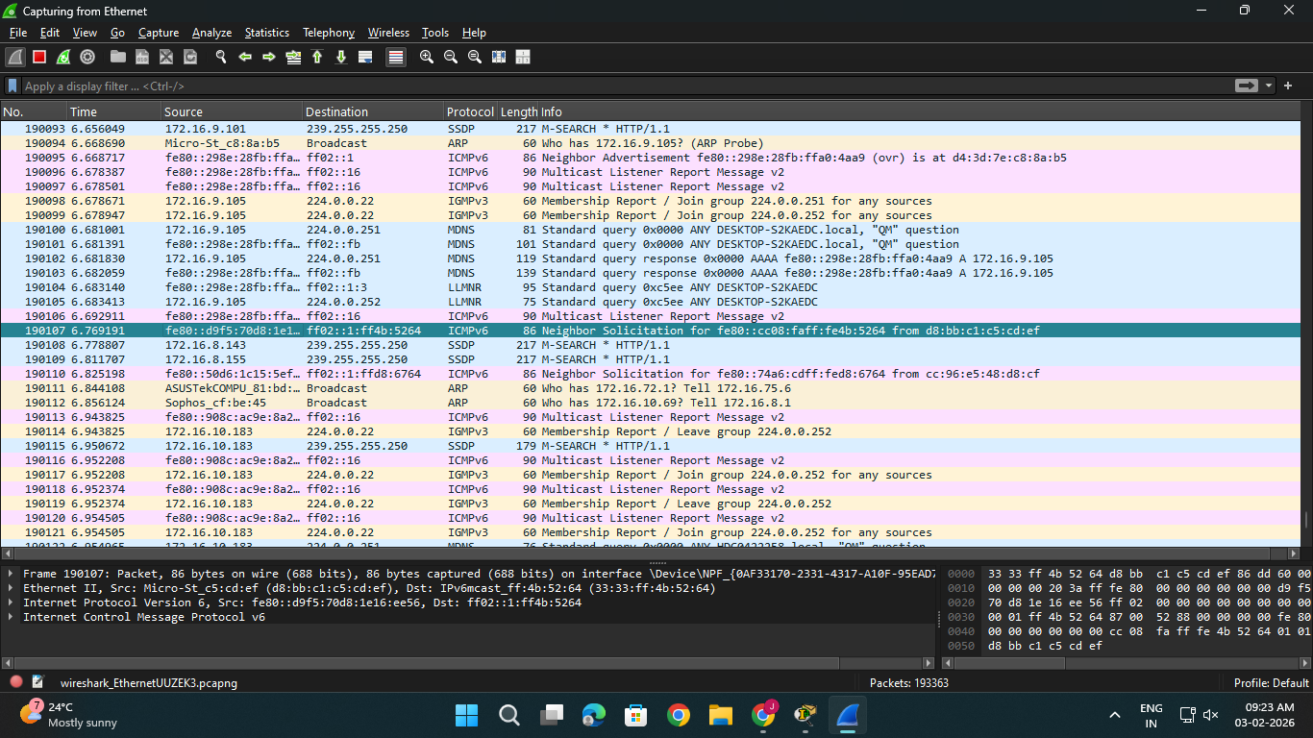

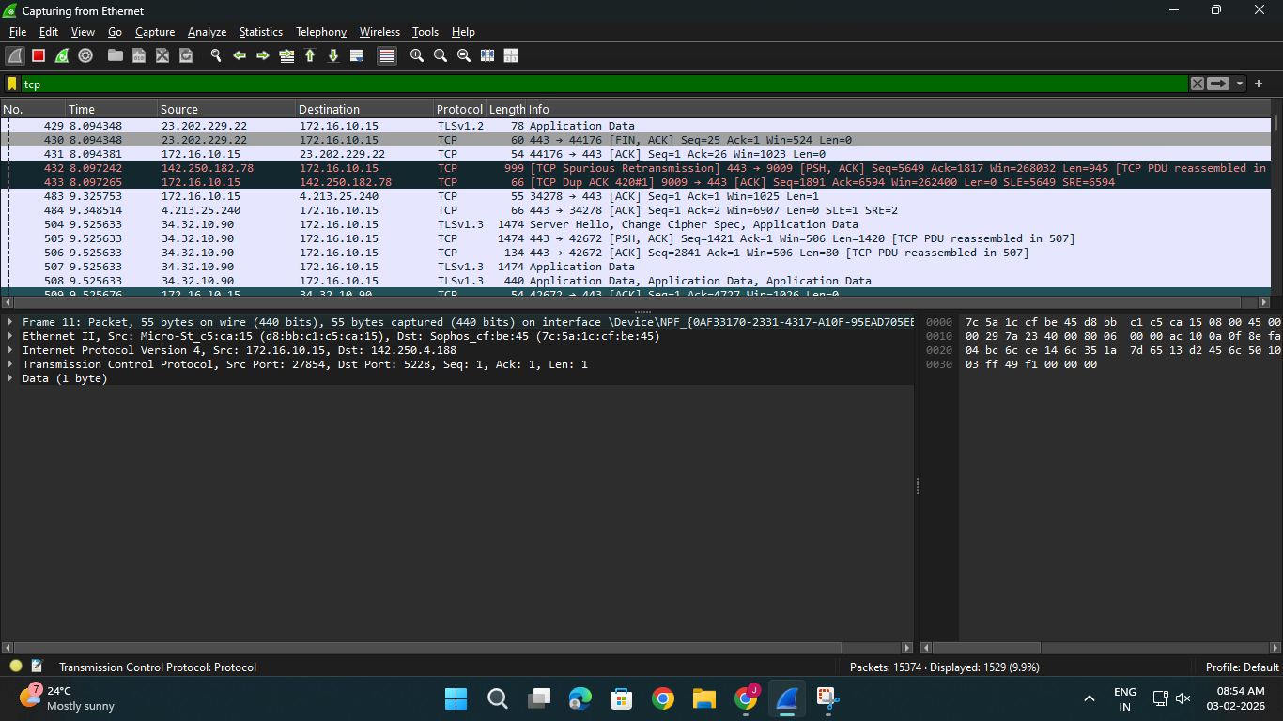

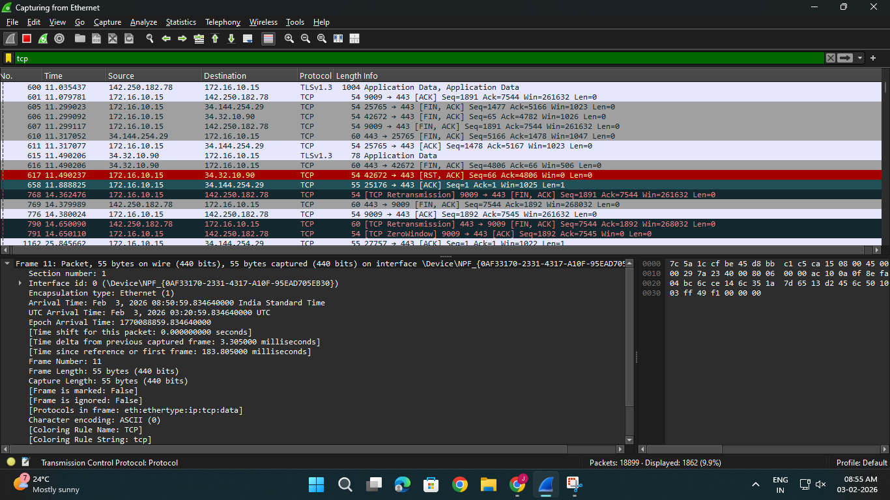

List of protocols:

- MDNS
- UDP
- NBNS
- LLMNR
- ARP
- IGMPv3
- SSDP
- DHCPv6
- STP
- ICMPv6
- BROWSER
- TCP
- QUIC
- UDP/XML
- MS-DO
- ICMP
- TLSv1.3
- DHCP
- TLSv1.2
- HTTP

Protocol Explanation:

- TCP - TCP (Transmission Control Protocol) is a protocol that allows devices to communicate reliably over a network. It ensures that data reaches the destination correctly and in the right order, even if parts of the network are slow or unreliable.
- UDP -User Datagram Protocol (UDP) is a Transport Layer protocol of the Internet Protocol (IP) that provides fast, connectionless, and lightweight communication between processes. It does not guarantee delivery, order, or error checking, making it suitable for real-time and time-sensitive applications such as video streaming, DNS, and VoIP.
- ARP - ARP (Address Resolution Protocol) maps an IPv4 address to the corresponding MAC address on a local network so frames can be delivered to the correct device.
- Resolves IP addresses to MAC addresses for local communication
- Works only within the same broadcast domain (LAN)
- Operates directly over link-layer technologies such as Ethernet
- Essential for delivering frames to the correct device
- HTTP - HTTP stands for Hypertext Transfer Protocol, and it’s the system that allows communication between web browsers (like Google Chrome or Firefox) and websites. When you visit a website, your browser uses HTTP to send a request to the server hosting that site, and the server sends back the data needed to display the page.
- ICMP -Internet Control Message Protocol (ICMP) is a network layer protocol widely used by network devices such as routers, gateways and hosts to send error messages and operational information. Since the Internet Protocol (IP) itself does not have an inbuilt error-reporting or correction mechanism, ICMP is a supporting protocol within the IP suite that helps in reporting errors and sending diagnostic messages. It is primarily used for:
- Error reporting: When data packets cannot reach their destination due to issues such as unreachable hosts, timeouts or fragmentation errors.
- Operational queries: For example, echo requests and replies used in tools like ping.
RESULT:
Thus the various protocols operated and explain 5 minimum protocols such as UDP, ARP, TCP in detail using wireshark filter and flow graph has been understood.

